**ИИН-820817401384**

**Ватсап телефоны-87073183215**

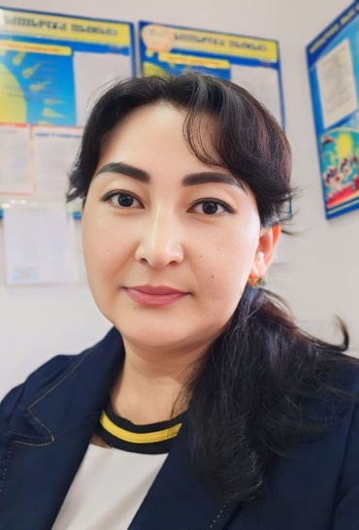

**ТЕНГЕБЕКОВА Гулмира Максутовна,**

**№27 «Мәртөбе» атындағы жалпы орта білім беретін мектебінің ағылшын тілі пәні мұғалімі.**

Шымкент қаласы

**GREETINGS AND NAMES**

|  |  |
| --- | --- |
| **Learning objectives** | 3.1.1.1 Recognise the sounds of phonemes and phoneme blends in words;  3.1.2.1 Recognise familiar words with visual support;  3.1.3.1 Understand a range of short classroom instructions. |
| **Lesson objectives** | **Learners will be able to:**   * **introduce the characters;** * **practise introducing oneself and greeting others;** * **respond to basic questions with single words or short responses.** |
| **Plan** | |

|  |  |  |  |  |
| --- | --- | --- | --- | --- |
| Stages/Time | Teachers actions | Students’ actions | Assessment criteria | Resources |
| Beginning of the lesson  Warming-up  7 min | **Organization moment:**  Welcome the pupils and introduce the topic of the lesson.  **Warming up**  **“Hello” song**  Welcome your class by saying Hello several times. Write your name on the board. Point to your name and to yourself and say: Hello, I’m (Gulmira Maksutovna).  Encourage the pupil to respond. Hand out the photocopies of the name tags, filled in with the pupils’ names. The pupils colour their name tags using their favourite colour. | Students say Hello.  Students sing a song “Hello”  e.g., Pupil 1: Hello, I’m (Batyr). (points to name tag)  Pupil 2: Hello, I’m (Bagym). (points to name tag) etc | The teacher  assesses learners for their ability.  “Good job!  Well done!”  Formative Assessment  https://coolsen.ru/wp-content/uploads/2022/02/52-20220208_175523.png | Laptop and Projector  “Hello”song  <https://www.youtube.com/watch?v=tVlcKp3bWH8>  Photocopies of the name tags,  one per pupil, from the Teacher’s Resource Material for the Beginning the Lesson activity; |
| Middle of the lesson  Presentationand Practice.  30 min | **To present the characters and greetings/ introductions**  Present the characters by pointing to them, one at a time, and saying their names. Explain that Elsa and Cody are brother and sister while Cody and Tara are their friends. Carlos has got a dog called Chico! | The pupils listen and point to the pictures.  The pupils listen, point to the pictures and repeat, chorally and/or individually. | **«Thumbs Up / Thumbs Down»** | Laptop and Projector  C:\Users\пк\Downloads\WhatsApp Image 2024-09-18 at 14.38.57.jpeg  Pb. p.7, ex.1 |
|  | Read out the example.  Divide the class into groups. The pupils act out similar dialogues. Go around the classroom providing any necessary help. Ask some groups to come to the front of the classroom and act out their dialogues.  **Play the Guess Who? game.**  Ask a pupil to come to the front of the classroom with their back to the class. | A pupil from the class says: Hello, (Ulan). The pupil at the front has to guess who it is and respond: Hello, (Sultan). If (Ulan) guesses correctly, (Sultan) takes his place at the front and the game continues. e.g. Sultan: Hello, (Ulan)! Ulan: Hello, (Sultan)! etc | The teacher  assesses learners for their ability.  “Good job!  Well done!”  During the lesson some tasks differentiated by outcomes of the students and by their abilities. | Activity book  Pb. p.7,  ex.2-3  Classic board game Guess Who? is being adapted into a television game show  | Dicebreaker |
| End of the lesson  8 min | **FEEDBACK**  Traffic light method is used to find out was the lesson clear or not. Use the stickers. |  | |  |